CelDial: Case Study Analysis

INTRODUCTION
CelDial Corporation is a manufacturer of cellular telephones and expanded its business to telecommunication products namely: new plants, sales offices and stores to increase their customer demand. CelDial′s growth has started to level off, and management is refocusing on the performance cost and revenue.
The cost and revenue details are available at the company as a whole but a part of data is available at manufacturing or sales outlet. In order to solve this, IT has suggested to build a data warehouse based on their potential costs and benefits.
OBJECTIVE :

To create a data warehouse to facilitate the analysis of cost and revenue data for products manufactured and sold by CelDial.

1. Operational System

An operational system is a term used in data warehousing to refer to a system that is used to process the day-to-day transactions of an organization. These systems are designed in a manner that processing of day-to-day transactions is performed efficiently and the integrity of the transactional data is preserved.

The purpose of dimensional modeling is to enable business intelligence (BI) reporting, query, and analysis. The key concepts in dimensional modeling are facts, dimensions, and attributes. There are different types of facts (additive, semiadditive, and nonadditive), depending on whether they can be added together. Dimensions can have different hierarchies, and have attributes that define the who, what, where, and why of the dimensional model. The grain, or level of granularity, is another key concept with dimensional modeling because it determines the level of detail. Facts, dimensions, and attributes can be organized in several ways (star, snowflake, multidimensional, and multifact star), called schemas. The choice of schema depends on variables such as the type of reporting that the model needs to facilitate and the type of BI tool being used. Building a dimensional model includes additional puzzle pieces such as calendar and time dimensions; and more complicated pieces such as conforming, degenerative, and role-playing dimensions; and consolidated fact tables.

2. Data warehouse System:
Before we delve into the details of dimensional modeling, it is helpful to focus on the fundamental goals of data warehousing and business intelligence. The goals can be readily developed by walking through the halls of any organization and listening to business management. These recurring themes have existed for more than three decades:
■ We collect tons of data, but we can’t access it.
■ We need to slice and dice the data every which way.
■ Business people need to get at the data easily.
■ We spend entire meetings arguing about who has the right numbers rather than making decisions and we want people to use information to support more fact-based decision making.
The DW/BI system must make information easily accessible,must present information consistently, must present information in a timely way and must adapt to change.

SCOPE OF THE PROJECT :

The project has limited to direct costs and revenues associated with products and only component costs can be included and flexible enough to accommodate future changes. The product information added to the company's records.A product has a base set of common components. Additional components are added to the base set to create specific models of the product. Currently, CelDial has 300 models of 10 models per week experience a cost or price change. When a model is deemed eligible for discounting, the salesperson may discount the price if the customer buys a large quantity of the model or a combination of models . A work order is created to cause more of the model to be manufactured.The sales outlet is responsible for selling the model and to stop making a model, data about the model is kept on file for six months .
There are two types of sales outlets: corporate sales office and retail store. A corporate sales office sells only to corporate customers. Corporate customers and are charged the suggested wholesale price for a model unless a discount is negotiated.
For each product model, the cost of each component is multiplied by the number of components used to manufacture the model. The sum of results for all components that make up the model is the cost of that model. For each product model, the negotiated unit selling price is multiplied by the quantity sold. The sum of results for all order lines that sell the model is the revenue for that model. When trying to relate the cost of a model to its revenue.

UNDERSTANDING & ANALYZING REQUIREMENTS - Design Approach:

Conceptual Model Design
Entity Details
ENTITY | FACT/DIMENSIONS NO.OF ATTRIBUTES
Inventory | Fact 5
Manufacture | Dimension 4
Product | Dimension 6
Order | Dimension 5
Order details | Dimension 5
Sales | Fact 9
Customer | Dimension 5
Time | Dimension 5
Sales outlet | Dimension 7

Logical to Physical Design Phase (Graphical)
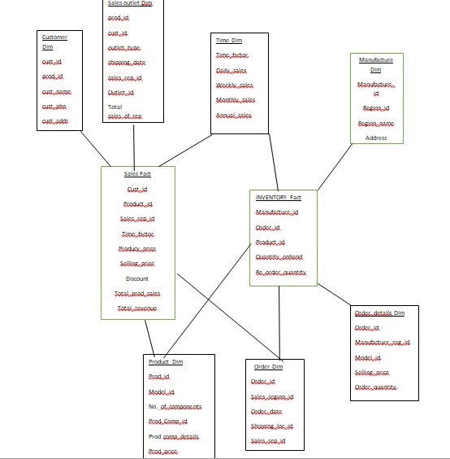

Required Trace Ability Matrix

SUBJECT AREA | KEY BUSINESS MEASURES | GRANULARITY | DIFFERENT KIND OF ANALYSIS | DIMENSIONS INVOLVED IN ANALYSIS
Sales | Total revenue,total cost | daily | - Total revenue details of each model from each region.  - Quantity of products eligible for discount.  - Total number of sales on daily basis. | Sales outlet, product,Time,  customer
Inventory | Re-order details,quantity, | daily | - Available quantity of products and re-order quantity of products. | Manufacture, time,order

Fact  Dimension | Total Qty sold | Total Qty produced | Re-Order Level | Total Revenue | Total Cost | Discount
Inventory |  | x | x
Time | x | x | x | x | x | x
Manufacture |  | x | x |  | x
Order_details |  |  | x
Product | x | x | x | x | x | x
Customer
Sales | x |  |  | x | x | x

Data Usage |  | Standard
DAILY |  | DATE
WEEK |  | VARCHAR2(10)
MONTH |  | VARCHAR2(3)
CUSTOMER_ID |  | NUMBER(8)
NAME |  | VARCHAR2(20)
CUSTOMER_ADDRESS |  | VARCHAR2(30)
CUSTOMER_EMAIL |  | VARCHAR2(15)
CUSTOMER_PHONE |  | NUMBER(10)
LOCATION_ID |  | VARCHAR2(4)
ORDER_ID |  | NUMBER(8)
OUTLET_ID |  | VARCHAR2(8)
TOTAL_COST |  | NUMBER(8,2)
TOTAL_REVENUE | NUMBER(8,2)
TOTAL_QTY_SOLD | NUMBER(8)
TOTAL_REVENUE |  |  |  | NUMBER(8,2)
TOTAL_QTY_SOLD |  |  |  | NUMBER(8)
DISCOUNT |  |  |  | NUMBER(8)
PRODUCT_ID |  |  |  | NUMBER(8)
MODEL_ID |  |  |  | NUMBER(8)
PREVIOUS_COST |  |  |  | NUMBER(8)
ADDRESS |  |  | VARCHAR2(90)
MANUFACTURING_ID |  |  | NUMBER(68)
Region |  |  | Number(4)
PLANT_ID |  |  | NUMBER(46)
QUANTITY_ONHAND |  |  | NUMBER(45)
REORDER_LEVEL |  |  | NUMBER(25)
PHYSICAL DESIGN:

Operational to Dimensional Model - Map:

Map:
The project contains two fact tables:
1.inventory
2.sales
Inventory: inventory contains manufacture,order,product,time and order detailes. This contains track of available quantity of products and re order quantity of products , the minimum availability of products and products avaiable at different plants and regions.
Sales :sales contains order,time,product,customer and sales outlet. This contains the total revenue details of each model from each region , quantity of products eligible for discount and total number of sales on daily basis.

Presented by
D.K.A.VISALAKSHI
VARANASI TEJA

